**-- SQL DEVELOPER TASK - 2**

**-- Step 1: Create Required Tables**

**-- Courses Table use studentmanagement ;**

CREATE TABLE Courses ( course_id INT AUTO_INCREMENT PRIMARY KEY, course_name VARCHAR(100), course_description TEXT );

**-- Enrolments Table**

CREATE TABLE Enrolments ( enrolment_id INT AUTO_INCREMENT PRIMARY KEY, student_id INT, course_id INT, enrolment_date DATE, FOREIGN KEY (student_id) REFERENCES Students(StudentID), FOREIGN KEY (course_id) REFERENCES Courses(course_id) );

**-- Step 2: Insert Sample Data**

**-- Insert into Courses**

INSERT INTO Courses (course_name, course_description) VALUES ('Mathematics', 'Advanced mathematics course'), ('Physics', 'Basic physics course'), ('Chemistry', 'Organic and inorganic chemistry'), ('Computer Science', 'Intro to programming and databases');

**-- Insert into Enrolments**

INSERT INTO Enrolments (student_id, course_id, enrolment_date) VALUES (1, 1, '2024-01-10'), (2, 2, '2024-01-12'), (1, 3, '2024-02-01'), (4, 2, '2024-03-15'), (5, 1, '2024-04-20'), (2, 1, '2024-05-10'), (6, 4, '2024-05-18');

**-- Task 1: List all students and the courses they are enrolled in**

SELECT s.Name AS StudentName, c.course_name AS CourseName FROM Students s INNER JOIN Enrolments e ON s.StudentID = e.student_id INNER JOIN Courses c ON e.course_id = c.course_id;

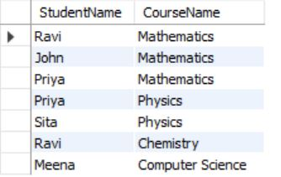

**Explanation:**

* Performs two INNER JOINs: Students → Enrolments → Courses.
* Returns student names along with their respective course names.

**-- Task 2:** **Find number of students enrolled in each course**

* SELECT c.course_id, c.course_name, COUNT(e.student_id) AS StudentCount FROM Courses c LEFT JOIN Enrolments e ON c.course_id = e.course_id GROUP BY c.course_id, c.course_name;

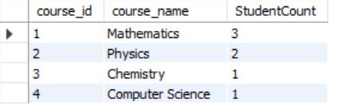

**Explanation:**

* LEFT JOIN ensures all courses are included, even with no students.
* GROUP BY groups data by each course.
* COUNT() gives the number of students per course.

**-- Task 3:** **List students who have enrolled in more than one course**

SELECT s.StudentID, s.Name, COUNT(e.course_id) AS NumberOfCourses FROM Students s JOIN Enrolments e ON s.StudentID = e.student_id GROUP BY s.StudentID, s.Name HAVING COUNT(e.course_id) > 1;

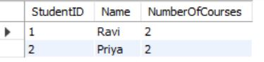

**Explanation:**

* Groups students and counts their courses.
* HAVING COUNT > 1 filters only those enrolled in more than one course.

**-- Task 4: Find courses with no enrolled students**

SELECT c.course_id, c.course_name FROM Courses c LEFT JOIN Enrolments e ON c.course_id = e.course_id WHERE e.enrolment_id IS NULL;



**Explanation:**

* LEFT JOIN brings in all courses.
* WHERE e.enrolment_id IS NULL filters out the ones with no enrollments.